CREATING TABEL
CREATE TABLE employees (
emp_id INT PRIMARY KEY,
emp_name VARCHAR(50) NOT NULL,
department VARCHAR(30),
salary DECIMAL(10,2),
manager_id INT,
phone VARCHAR(15),
commission DECIMAL(10,2)
);

INSERTING ROWS
INSERT INTO employees (emp_id, emp_name, department, salary, manager_id, phone, commission)
VALUES (1, 'Alice Johnson', 'Sales', 55000.00, NULL, '9876543210', 5000.00);
INSERT INTO employees (emp_id, emp_name, department, salary, manager_id, phone, commission)
VALUES (2, 'Robert King', 'Executive', 120000.00, NULL, NULL, NULL);
INSERT INTO employees (emp_id, emp_name, department, salary)
VALUES (3, 'Priya Sharma', 'IT', 62000.00);
INSERT INTO employees (emp_id, emp_name, department, salary, manager_id)
VALUES (4, 'David Lee', 'Sales', 48000.00, 1);
INSERT INTO employees (emp_id, emp_name, department, salary, manager_id, commission)
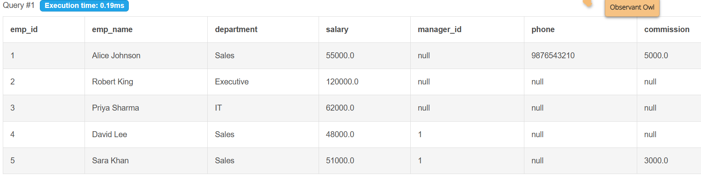
VALUES (5, 'Sara Khan', 'Sales', 51000.00, 1, 3000.00);
Replace NULLs with a default using COALESCE
SELECT emp_name, COALESCE(commission, 0) AS commission, COALESCE(phone, 'Not Provided') AS phone FROM employees;
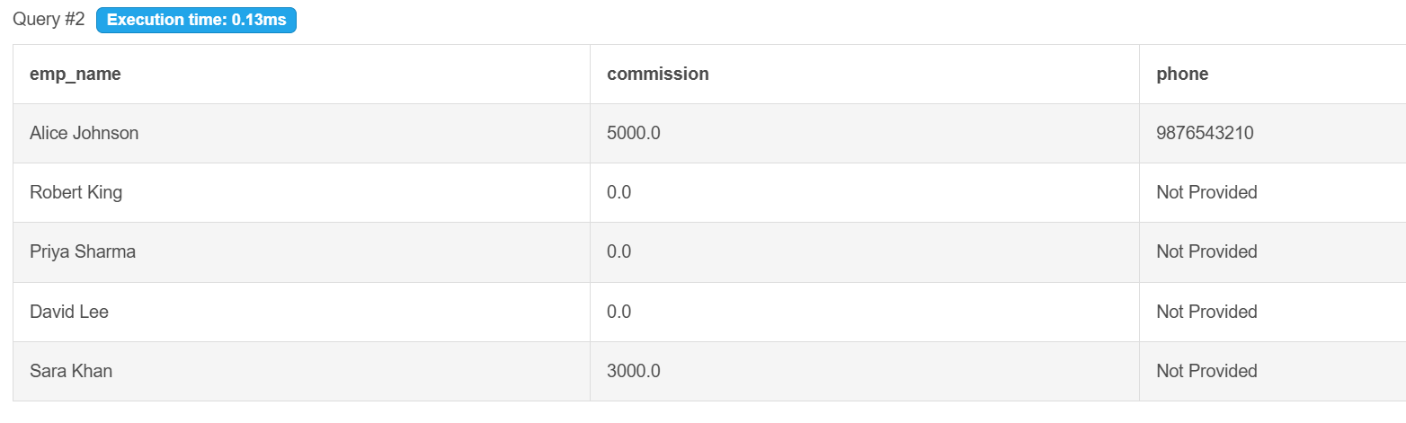
Sorting NULLs predictably
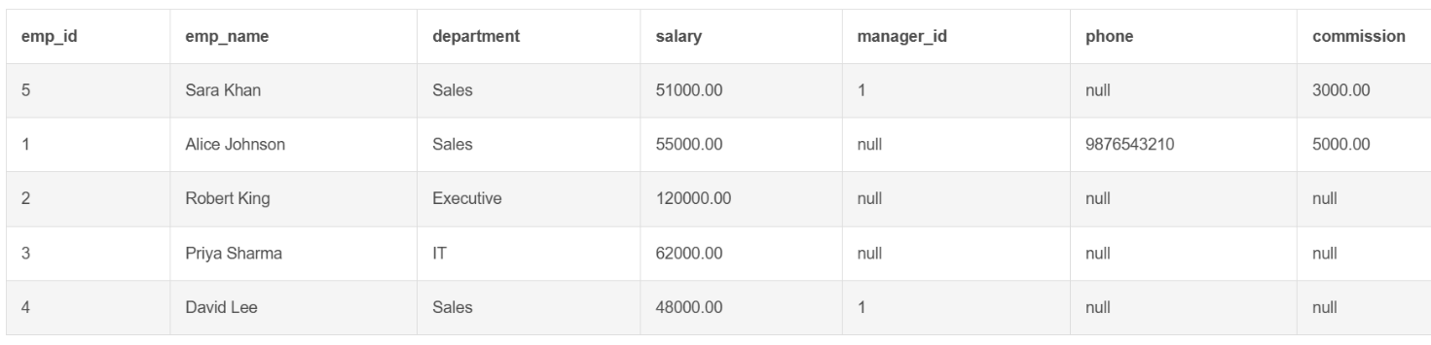
SELECT * FROM employees ORDER BY commission NULLS LAST;

UPDATE AND DELETE— Fixing/Setting NULLs
-- Give Priya a manager
UPDATE employees SET manager_id = 2 WHERE emp_id = 3;
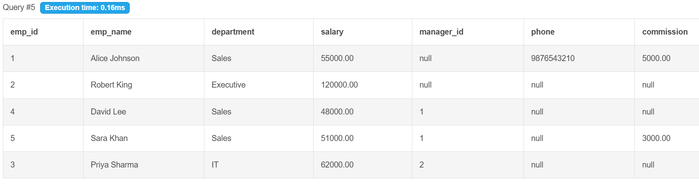
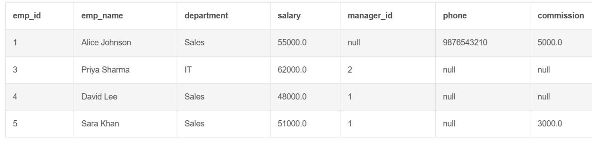
-- Delete a specific employee
DELETE FROM employees WHERE emp_id = 2;

